|  |  |  |  |  |  |
| --- | --- | --- | --- | --- | --- |
| Date | 7-Dec-22 | | | Tester Name | Mohammad Yusuf |
| Environment | Penfax - Test | | | Login used |  |
| Operating System | Select OS | Version: | Update: | | |
| Software Used | Select Software | Version: | Update: | | |
| Select Software | Version: | Update: | | |
| Release version |  | | | | |
| Title | M17 Contributions & DCT | | | | |
| Test Type | Regression | | | | |
| Test Scenario | M17.21 View and Export Audit Reports | | | | |
|  |  | | | | |
| Expected Results | Audit Report should show all the errors with details.  Report should be exported to excel and PDF format. | | | | |
| Pass/Fail | Fail | | | JIRA# | N/A |

Describe your steps with screenshots:

1. Log into MEPP DCT and select the Employer from the dropdown.

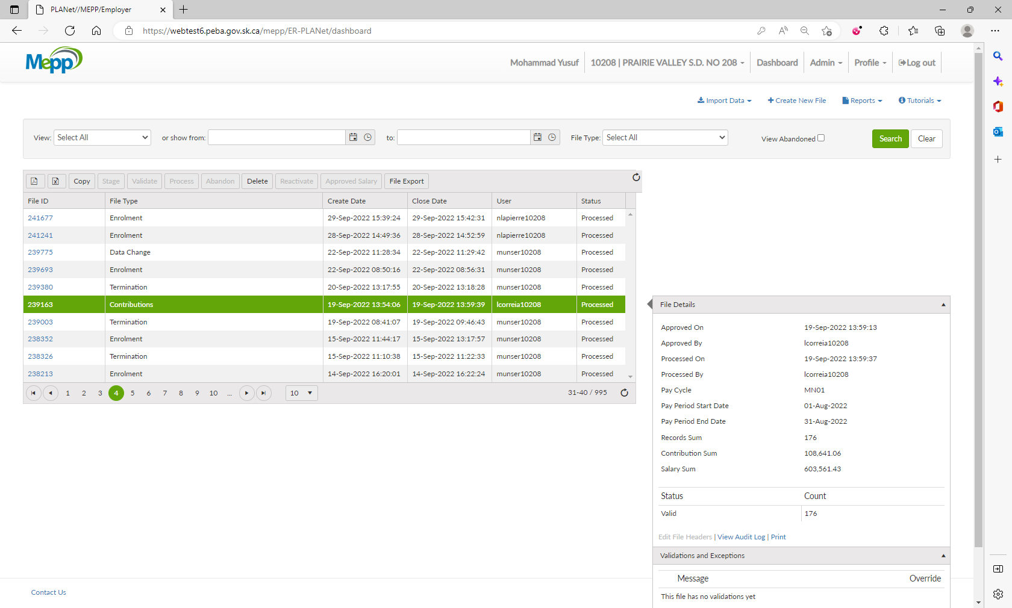

1. Click on any File ID.

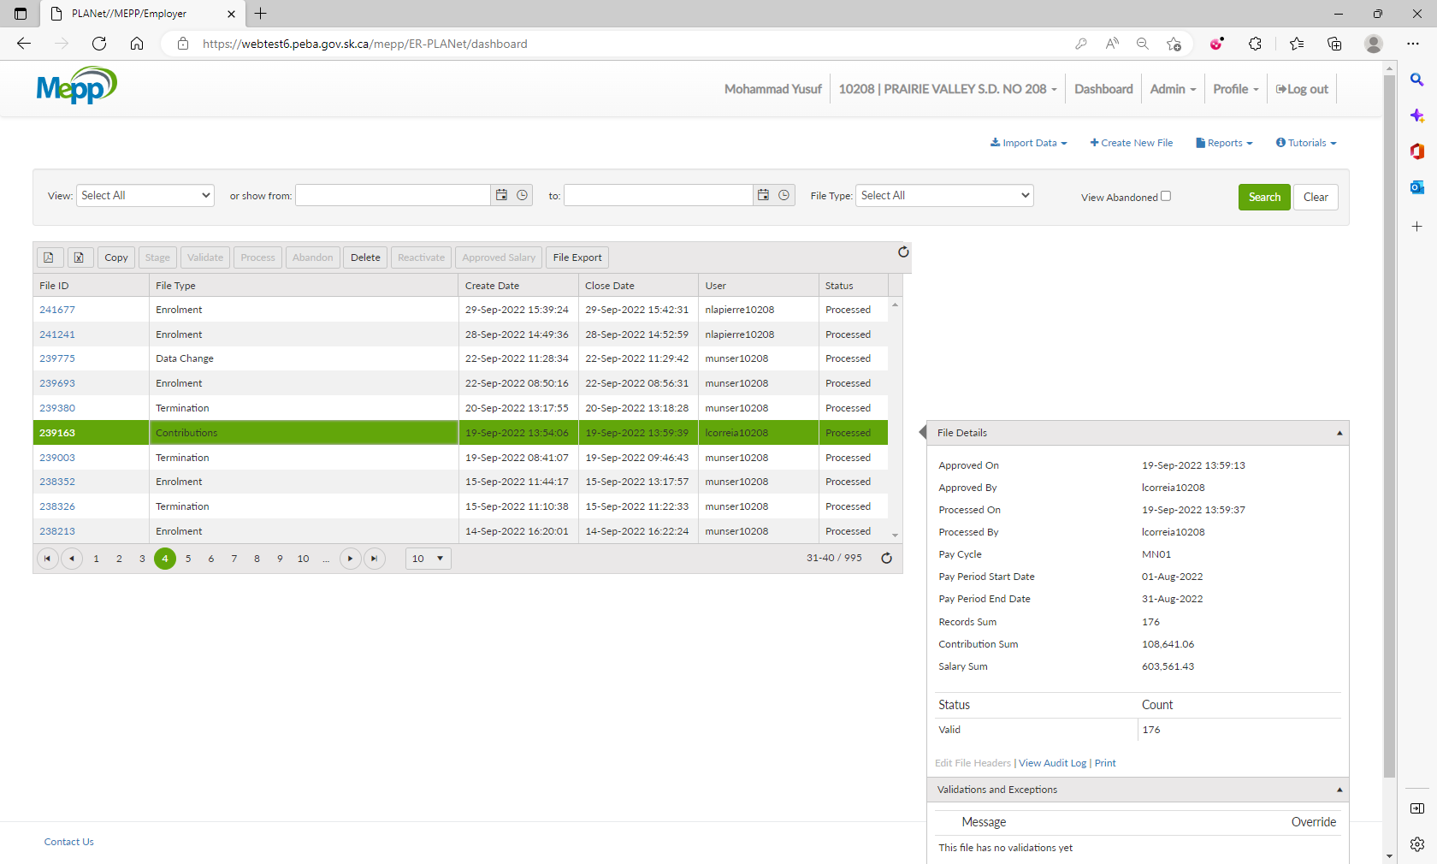

1. Click on Reports.

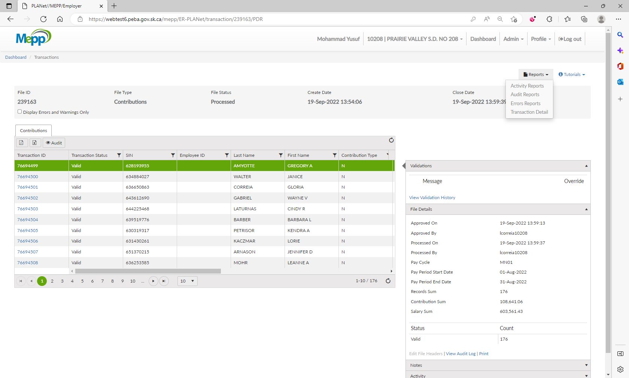

1. Select Audit Report from the dropdown.

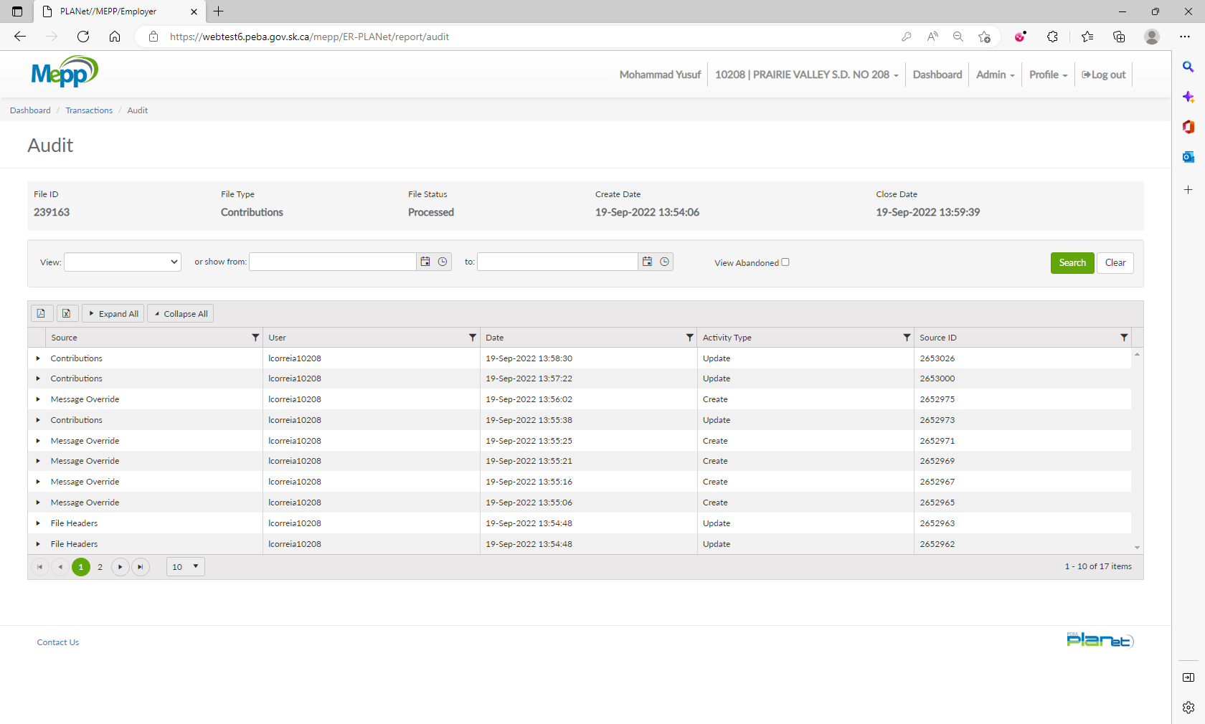

1. Audit Report
2. Click on Export to Excel.

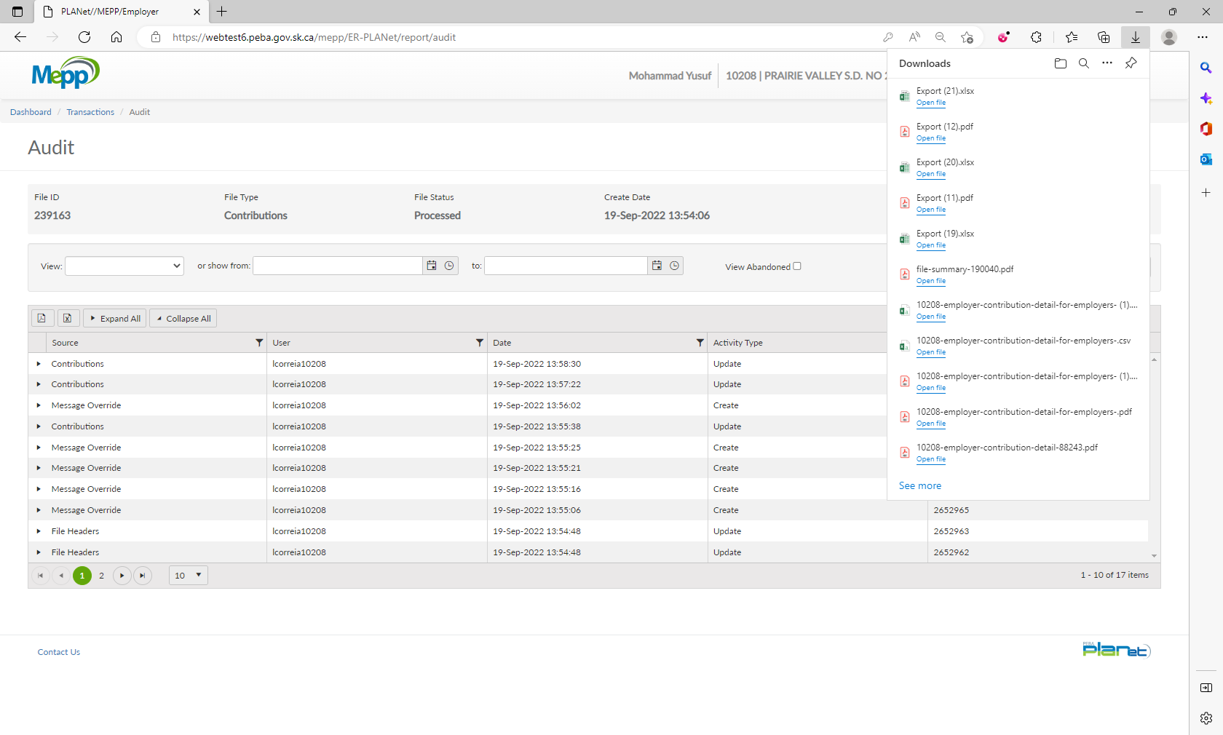

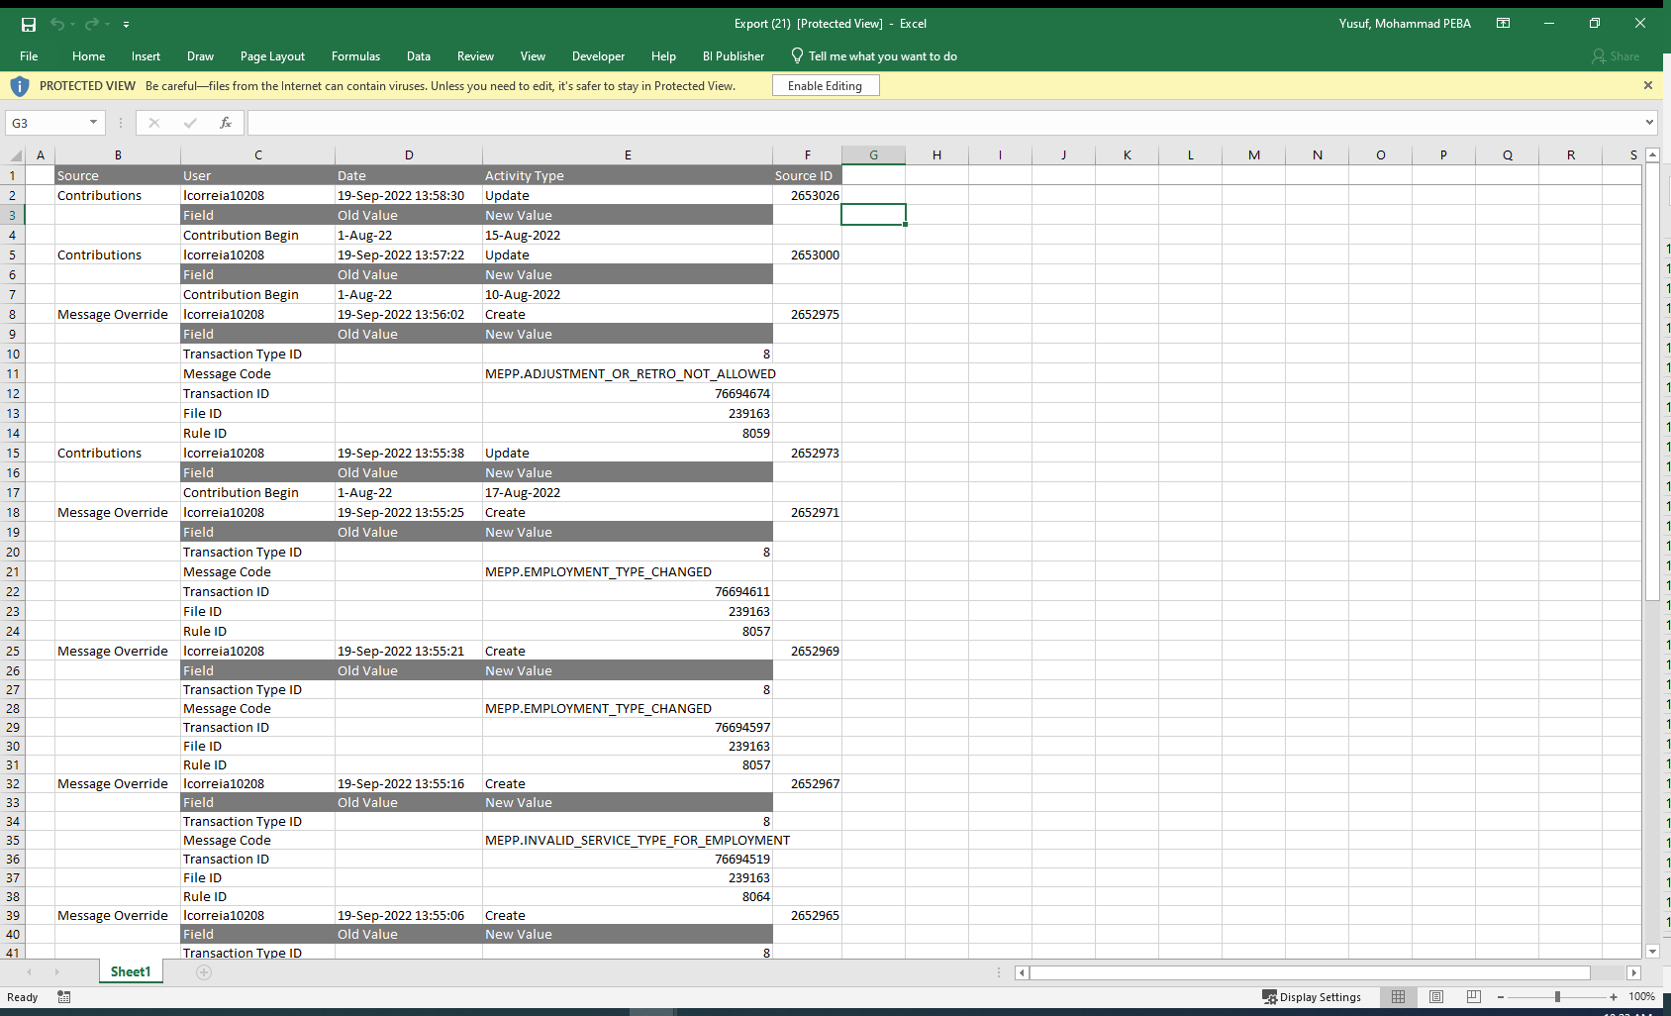

1. Click on Export to PDF.

